# 1-28-2020 SCRUM Meeting Notes

time: 5:03 – 5:10 PM

Scrum Master: Milo McCarty

RN = React Native

LL = Life Log

JS = Java Script

Milo—been working on tutorial of React Native. Finding JS difficult. Found some prospective users for LL.

Eric—Got Git to work and download the RN LL code. Working on adding item.

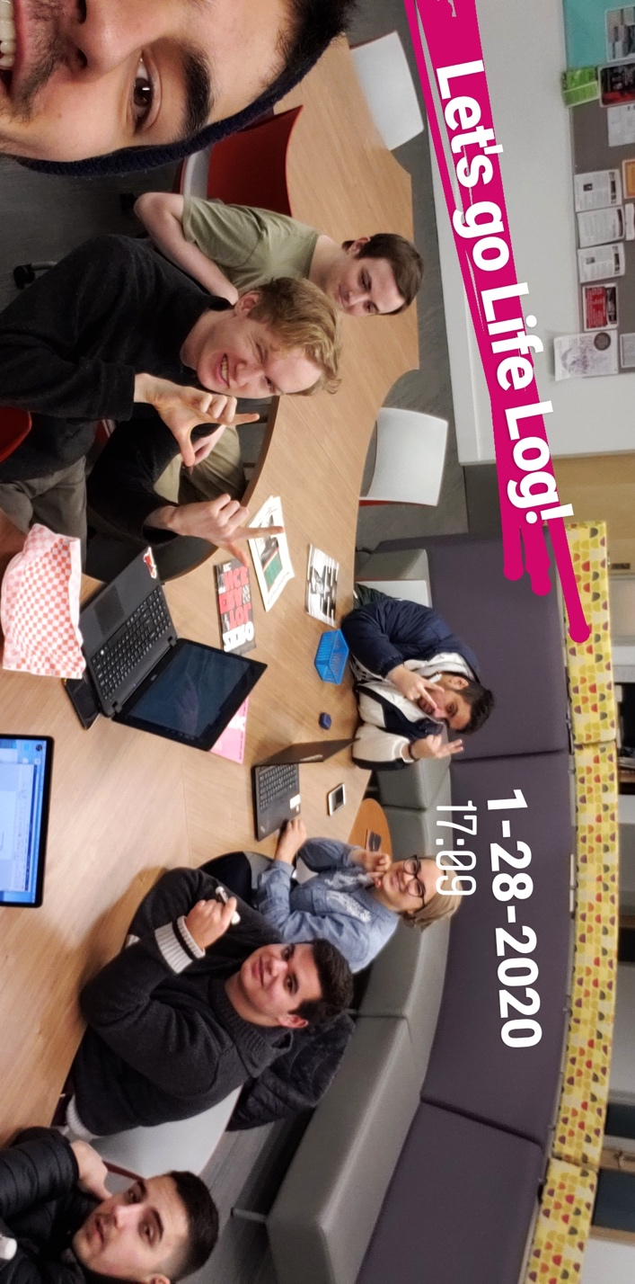Dylan: Got any code to run in React Native. Found 2 tablets with NFC reader for testing. NFC React native

Guzel, Nissir, Jacob: got Mongol DB to work. We have a connection to the server.

They tried adding password and it got the DB to work. All

Jacob: working on JS code. Recently has been having trouble with learning JS.

Josh: Java script sucks and is terrible. Wants to jump straight to working with NFCs.